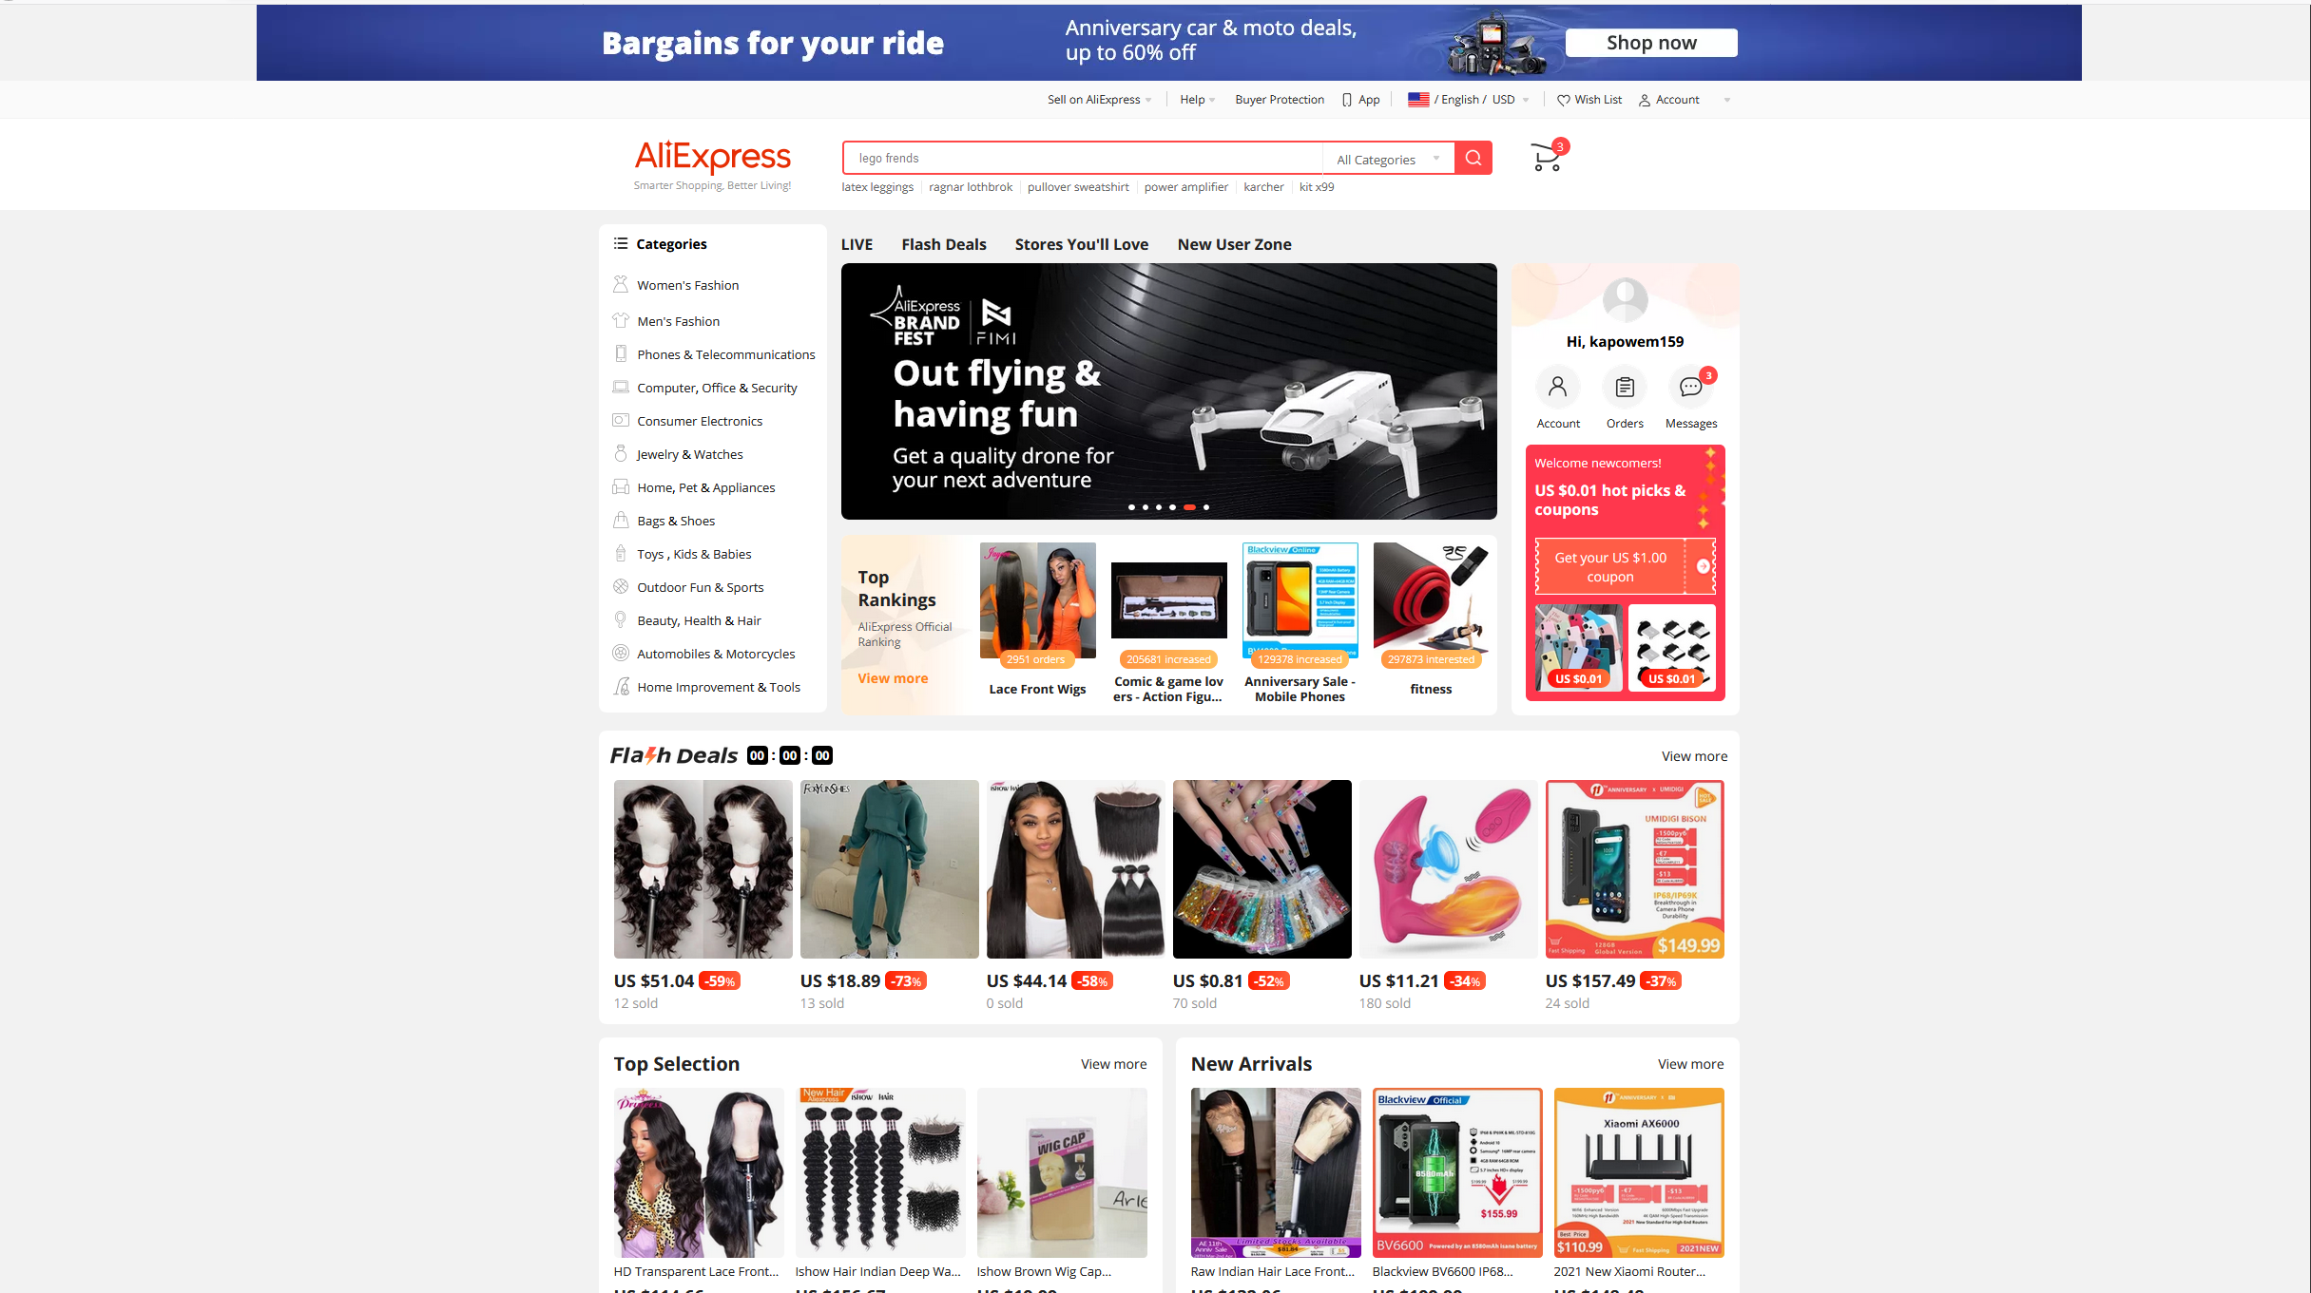

Control

* Control is a tool used to limit the expertise required for any new users but after the user becomes more experienced the need for control should be decreased or removed. Control is a way to help new users become more experienced/comfortable with the system by making it easier for them when they initially using it.
* Because are the current stage of this website it is very confusing. But having some process that will allow the user to understand how to work it would be helpful. So, something like a tutorial process or a walkthrough video that only shows up if the user allows it. So eventually once the user becomes experienced/comfortable they can disable the walkthrough process.
* Because this website is really cluttered which distracts the users focus makes it hard to navigate and has a level of uncertainty with the number of options as well as several methods to do the same task.

Desire Line

* Desire line are alternate methods that have been traced by users’ paths to do a use a system more efficiently.
* This will help users navigate more efficiently or have a quality-of-life change. Creating a toolbar where users can navigate or a functionality where the user can view their wish list always will be helpful so the user never will need to leave the page.
* There already exists a toolbar but does not work properly and the toolbar only appears when the user is on the homepage. The toolbars purpose is to allow the user to take alternate paths which are more efficient using a shortcut system like a toolbar is just what this website needs.

Entry Point

* Entry point is the starting point of a system where users make their initial impression and their feels of the product.
* The home page for this website is the entry point and at its current state everything is on the home page and is not clear on what to do next. The entry point should include something brief where users can get a feel of the website.
* Including a brief introduction while having a neat navigation pane where users can visit different sections of the website. Since everything is cluttered creating something that is more spread out is just what this website needs.